**Lesson19 What is Azure Kubernetes Service**

**Notes: -**

**1-kubernets has container orchestration software that allow to manage containers and VMS hosting those container**

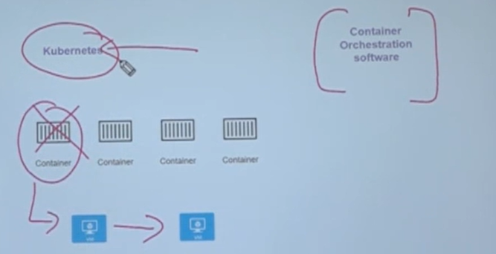

**2-we will create master node and install Kubernetes as well as the child nodes (VM) and in the master node we install the Kubernetes cluster and using tool called kubectl to allow the child nodes to upload custom images to master node**

